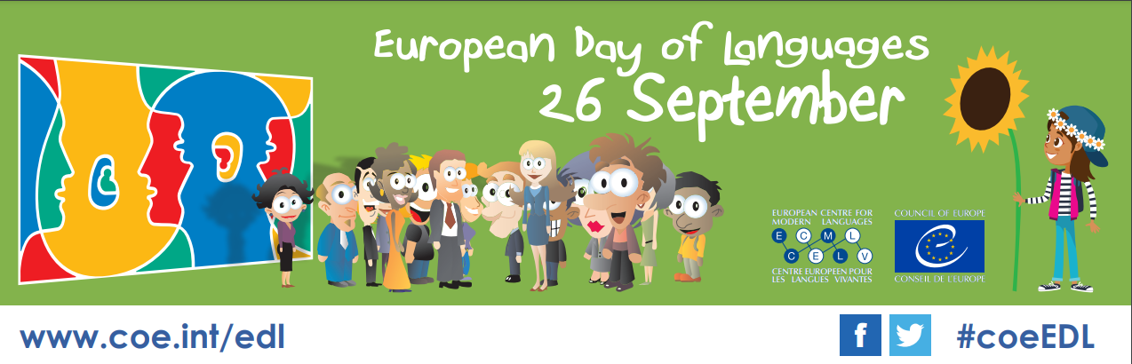

EDL MATERIAL 2022 ORDER FORM
to be completed and returned to the following address: neutorgasse@mbe-graz.at
by 16 September (we regret that no orders can be processed after this date)

The materials are provided free of charge, however a delivery fee of €50 (including VAT) per ‘standard pack’ is payable to the shipping company: Mail Boxes ETC.

The ‘standard pack’ is comprised of:

- 200 “Talk to me!” – Sets of 39 stickers
- 150 EDL fabric wristbands
- 100 EDL pens and pencils (mixture)

Please complete the details requested below and return this form to: neutorgasse@mbe-graz.at

I, [your name], wish to order promotional items for the 2022 European Day of Languages.

Number of packs required:

Total amount in Euros:

Date of request:

Desired delivery date:

The materials should be delivered to

Contact person:
Institution/School:
Delivery address:

Phone number:
E-mail:

* As this a standard offer, the number of the items indicated above cannot be changed. This offer is only available for as long as stocks last. Please note payment is exclusively by Paypal or prepayment by bank transfer.

In order to promote your event, Please upload details of your European Day of Languages’ celebrations to the Council of Europe EDL Calendar: http://edl.ecml.at/edlevents

